**IT252 Assignment-5**

NAME: SUYASH CHINTAWAR

ROLL NO.: 191IT109

TOPIC: SQL QUERIES 2

**OUTPUT SCREENSHOTS**

1. Write a query in SQL to obtain the name of the physician and the departments they are affiliated with.
2. 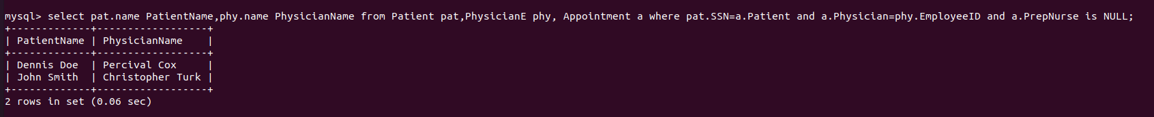Write a query in SQL to find the name of patients and their physicians who does not require any assistance of a nurse.
3. 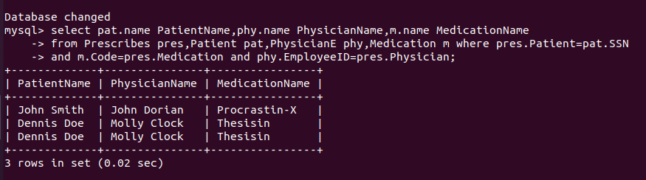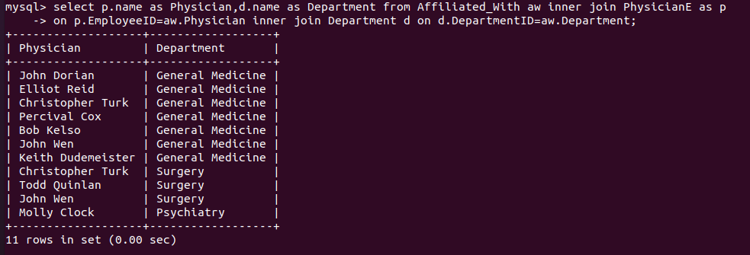Write a query in SQL to find the name of the patients, their treating physicians and medication.
4. 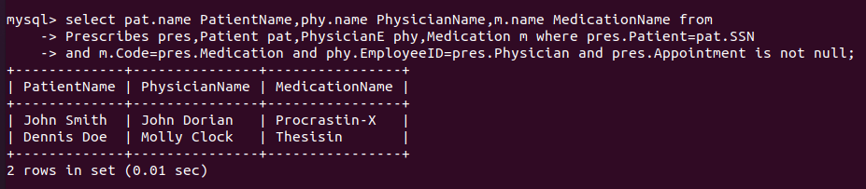Write a query in SQL to find the name of the patients who taken an advanced appointment, and also display their physicians and medication.
5. 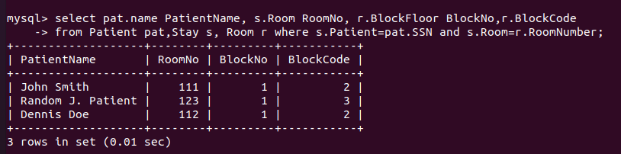Write a query in SQL to obtain the name of the patients, their block, floor, and room number where they are admitted.
6. 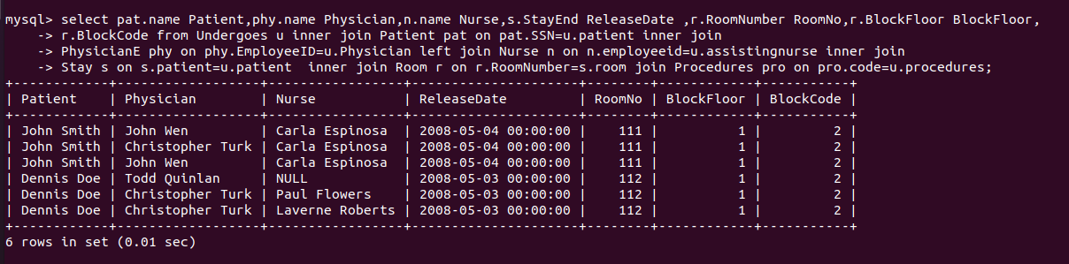Write a query in SQL to make a report which will show - a) name of the patient, b) name of the physician who is treating him or her, c) name of the nurse who is attending him or her, d) which treatment is going on to the patient, e) the date of release, f) in which room the patient has admitted and which floor and block the room belongs to respectively.
7. 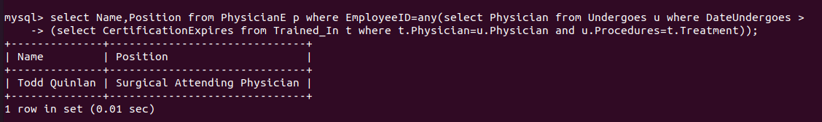Write a query in SQL to obtain the name and position of all physicians who completed a medical procedure with certification after the date of expiration of their certificate.
8. 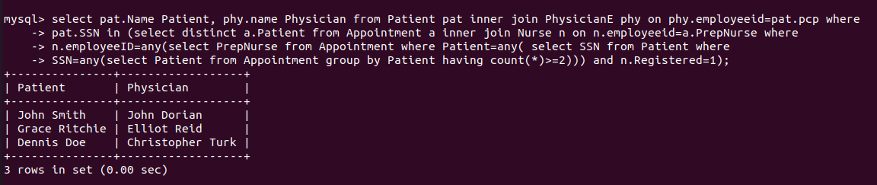Write a query in SQL to Obtain the names of all patients who had at least two appointment where the nurse who prepped the appointment was a registered nurse and the physician who has carried out primary care
9. Write a query in SQL to obtain the names of all patients who has been undergone a procedure costing more than $5000 and the name of that physician who has carried out primary care

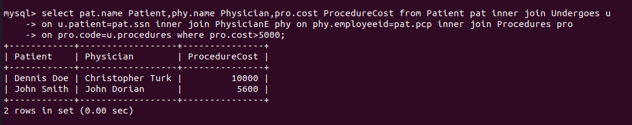

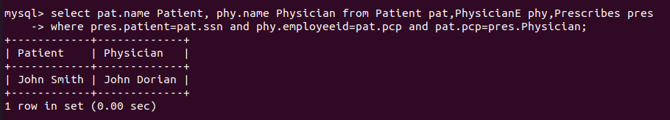10)Write a query in SQL to Obtain the names of all patients who has been prescribed some medication by his/her physician who has carried out primary care and the name of that physician.

THANK YOU